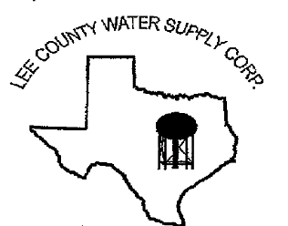

NOTICE OF MEETING
The Board of Directors of Lee County Water Supply Corporation
will have an open meeting on January 15, 2026, at 6:30 p.m. at the LCWSC Office located at
1598 S. Leon Street, Giddings, TX 78942

The agenda is as follows:
Call the meeting to Order by the Presiding Officer
- Pledges and Prayer
- Roll Call of Directors and Establish a Quorum
- Accept Director Absences
- Welcome and recognize Visitors and Guests
- Public Comments-(limit to 3 minutes and one speaker per issue)
- Approval of Minutes from the Regular Monthly Meeting held on December 18, 2025
- Discuss and take action on the Reallocation of Budgeted Funds
- Review of Financial Reports
- Managerial Reports:
- Paige Water Well Maintenance
- Staff Update
- VFD Mapping
- Meter Replacement Project
- Monthly Recap
- Activity Log
- Static Well Levels
- Yearly Usage Worksheet
- Rates & Fees
- General Manager Position
12. Discuss and take action on items to be included on the next monthly meeting agenda.
13. Pursuant to the Texas Government Code, the Board will convene in closed session to discuss the employment of the future General Manager
14. The Board will reconvene in open session and take any required action on the closed session item
15. Adjournment

If, during the course of the meeting, the Board determines that any item covered by the agenda should be discussed in closed session as authorized by Texas Government Code, Chapter 551, the Board may convene in closed session over said item. If a closed session is held on any item in accordance with Texas Government Code Section 551, the Board will reconvene in open session to take any required action.

Date: January 12, 2026

